Comp120-401 Software Engineering Fundamentals
Final Project Report
SipSaver Web Application
Professor: Justino Calvillo
Group 3
Ben Shlamovsky-Koroz
Tristan Bielby
Bianca Johnson

Software description: Sip Saver is a streamlined app built to help users track their coffee consumption and spending while effortlessly creating accurate shopping and order lists. The platform supports three main user types: Café Owners, Coffee Enthusiasts, and Guest Users.
Café Owners can manage bulk inventory orders, organise supplies, and assign roles or permissions to their staff. Coffee Enthusiasts can log their daily brews, monitor spending habits, and build personalized shopping lists for their next grocery run. Guest Users can explore Sip Saver’s features without creating an account, giving them a chance to test the app before committing.
Sip Saver removes the guesswork from coffee shopping and helps every user enjoy a smoother, more intentional morning brew. Screenshot of the landing page : 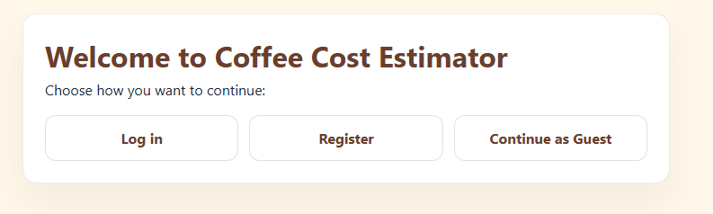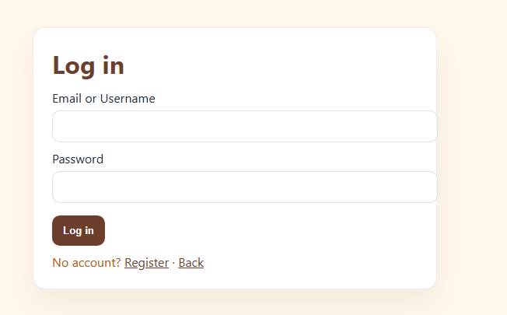
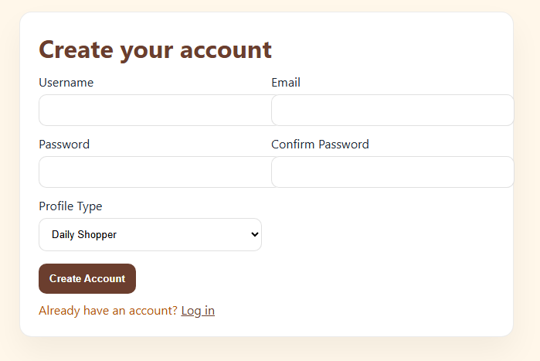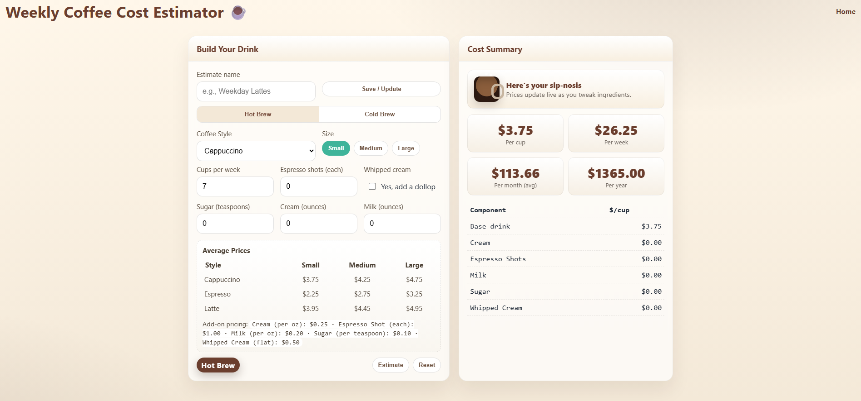

Provide at least 3 user roles, including a description for each

The 3 user roles for Sip Saver are Admin, Guest User, and Cafe Owner.
1. Admin
The Admin role is responsible for maintaining the overall functionality and stability of the app. Admins handle system updates, monitor performance, troubleshoot issues, manage user accounts, and ensure all features run smoothly. Their work keeps the entire Sip Saver ecosystem reliable and secure.
2. Café Owner
Café Owners use Sip Saver to streamline their business operations. They can create and manage bulk order lists, track supply usage, assign roles or permissions to employees, and oversee inventory trends. This role helps café owners stay organised, reduce waste, and keep their shop running efficiently.
3. Guest User
Guest Users can explore Sip Saver’s features without creating an account. They have limited access but can sample core tools, such as browsing the interface, testing simple tracking features, or previewing how shopping lists are generated. This role is designed to let new users try the app before committing to registration.

- Provide 10 user stories
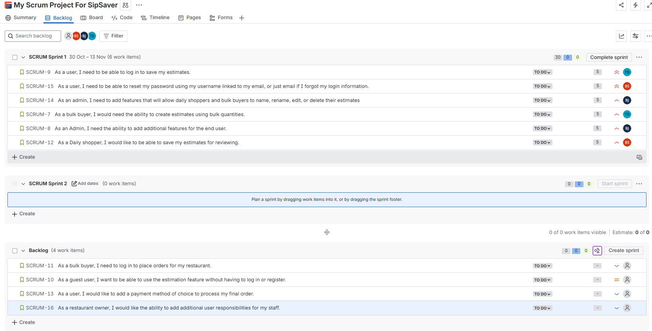

As a bulk buyer, I would need the ability to create estimates using bulk quantities.
Assigned to: Tristan
Priority: High

As an Admin, I need the ability to add additional features for the end user.
Assigned to: Bianca
Priority: High

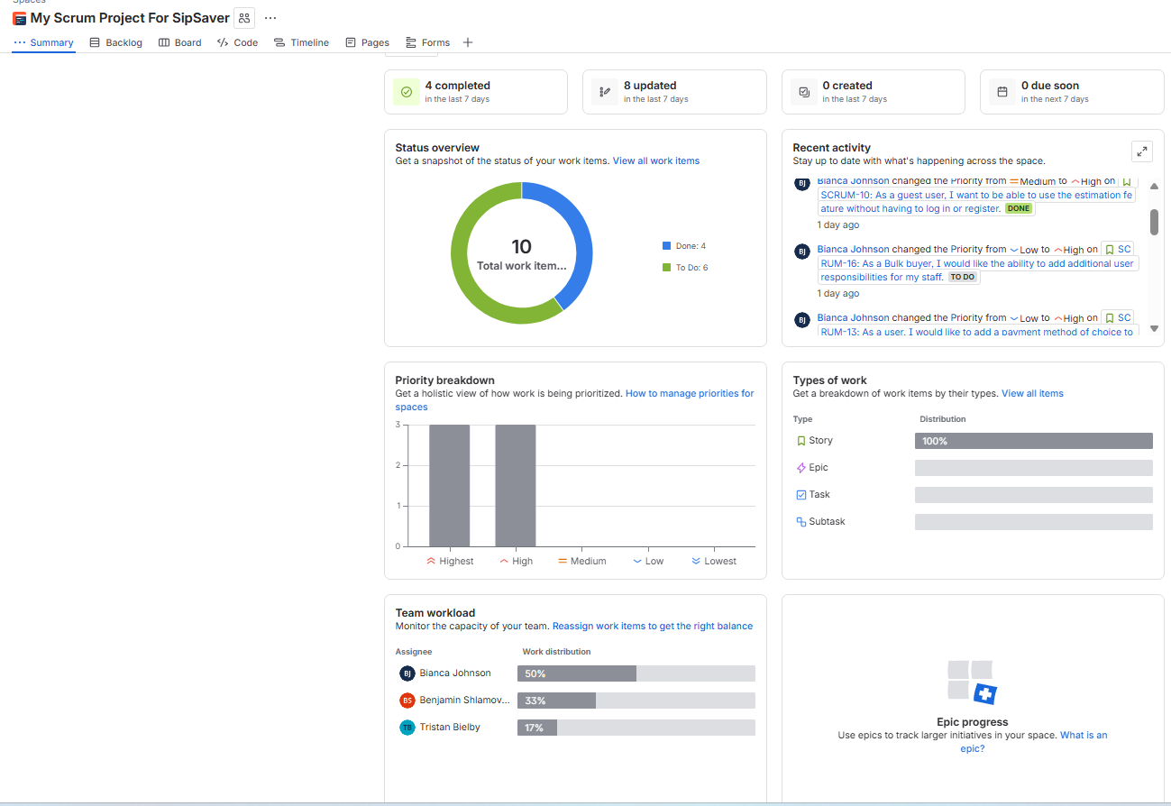

Scrum Meeting Minutes: Our team spent a total of 840 minutes working on our project.

Select a project collaboration software to communicate about the project: Our team used various means of software to communicate throughout the project development. We started on GitHub, but quickly evolved to Discord, Jira, PowerPoint, Google Docs, and emails.

User story Log in flow chart
